DeepLearning.AI Community Guide

Welcome!

If you are new to Discourse, here is a how-to guide to help you get started and get the most out of this Discourse forum.

Before diving into the details, please note that from now on we’ll only be using Discourse for learner support. For any questions or feedback about our courses, please post them in Discourse instead of the Coursera Forum. The Discourse invitation link only works once, but don’t worry once you have created an account on our Discourse, you’ll also have access to other future courses that you enroll in.

To allow quick and easy access to our DLAI Discourse instance, we recommend you bookmark this page in your browser: [https://community.deeplearning.ai/](https://discourse.deeplearning.ai/)

**Table of Contents**

You can click the link below to jump to a section. Or simply scroll down and read through each of the sections.

Overview of Discourse

Account Setup Instructions

Guidelines

Tips

User Trust Levels

### Overview of Discourse

Discourse framework/structure is :

**Discourse > Categories> Sub-categories > Topics > Replies**

1. **Categories:**Specializations are organized as categories in Discourse. These can be accessed by all learners. Some of the specializations you will notice on discourse are -
   * [Deep Learning Specialization](https://discourse.deeplearning.ai/c/deep-learning-specialization/6)
   * [Machine Learning Engineering for Production (MLOps)](https://discourse.deeplearning.ai/c/machine-learning-engineering-for-production/25)
   * [Practical Data Science](https://community.deeplearning.ai/c/pds/36)
   * [Natural Language Processing](https://community.deeplearning.ai/c/nlp/37)
   * [Generative Adversarial Networks (GANs)](https://community.deeplearning.ai/c/gans/38)
   * [AI for Everyone](https://community.deeplearning.ai/c/ai4e/42)
   * [AI for Medicine](https://community.deeplearning.ai/c/ai4m/43)
   * [TensorFlow Developer Specialization](https://community.deeplearning.ai/c/tf1/39)
   * [TensorFlow Data and Deployment Specialization](https://community.deeplearning.ai/c/tf2/40)
   * [TensorFlow Advanced Techniques Specialization](https://community.deeplearning.ai/c/tf3/41)
   * [The Machine Learning](https://community.deeplearning.ai/c/mls/221) Specialization

You may also see below specified categories, but request you to refrain from posting specialization or course related topics in these categories. Otherwise, there is a high chance that your posts may go unnoticed or unanswered for quite some time.

* + [General Feedback About Discourse Platform](https://community.deeplearning.ai/c/site-feedback/2)
  + [Awards and Recognitions](https://community.deeplearning.ai/c/awardsrecognitions/66)
  + [Careers/Job Opportunities](https://community.deeplearning.ai/c/random-discussions/careers/21)

1. **Sub-categories:**  
   Within any category related to a specialization, below sub-categories will be present-

* **Course [1, 2, 3…] / Week [1, 2, 3…]**
  + All communications, suggestions and feedback discussions pertaining to course content (such as videos, notebooks, labs, assignments, quizzes, reading items, graders, links/access issues etc.) need to be posted inside course sub-categories. For most specializations, there will be another level of sub-categorization by week.

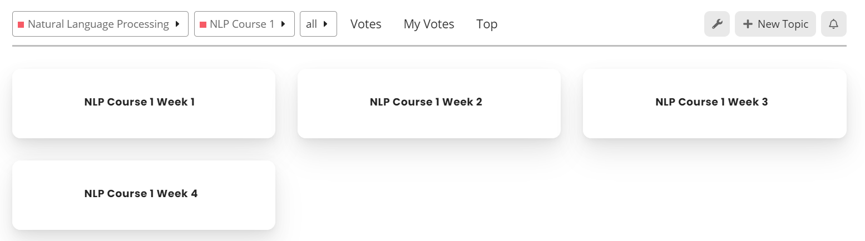

* + Note that the number of courses and number of weeks within the course will vary by specialization.
* **Introductions** 
  + This sub-category is meant for building network, rapport & interactions
* **Announcements**
  + This is where updates & news related to the specialization will be announced
* **Mentor Lounge** 
  + This is a private sub-category which is accessible only by mentors & staff.
* **Alpha Testing** 
  + This is a private sub-category which is accessible only to alpha testers of the courses/specialization and staff.
* **Beta Testing**
  + This is a private sub-category which is accessible only to alpha+beta testers of the courses and staff.

For example, within [Deep Learning Specialization Refresh](https://discourse.deeplearning.ai/c/deep-learning-specialization/6), below sub-categories will be listed:

* [DLS Course 1](https://discourse.deeplearning.ai/c/deep-learning-specialization/dls-course-1/12)
* [DLS Course 2](https://discourse.deeplearning.ai/c/deep-learning-specialization/dls-course-2/13)
* [DLS Course 3](https://discourse.deeplearning.ai/c/deep-learning-specialization/dls-course-3/14)
* [DLS Course 4](https://discourse.deeplearning.ai/c/deep-learning-specialization/course-4/15)
* [DLS Course 5](https://discourse.deeplearning.ai/c/deep-learning-specialization/dls-course-5/16)
* [DLS Introductions](https://discourse.deeplearning.ai/c/deep-learning-specialization/introductions/18)
* [DLS Announcements](https://discourse.deeplearning.ai/c/deep-learning-specialization/announcements/19)
* [DLS Resources](https://discourse.deeplearning.ai/c/deep-learning-specialization/deep-learning-resources/26)
* [DLS Mentor Lounge](https://discourse.deeplearning.ai/c/deep-learning-specialization/dls-mentors/17)

1. **Topics:**Within subcategories are topics. Topics are a collection of messages grouped under one umbrella. You can post questions, course feedback or initiate discussions by creating a new topic, or replying to existing topics. This is primarily how mentors will interact, support and answer learner’s queries.

At the end of the original post you will see a list of related topics that link to the one you are reading.

1. **Replies:**Press any composer Reply button to open the editor panel at the bottom of your browser.   
   To reply to a specific post in a topic, click the grey Reply button at the end of each post and your reply is linked to that post. 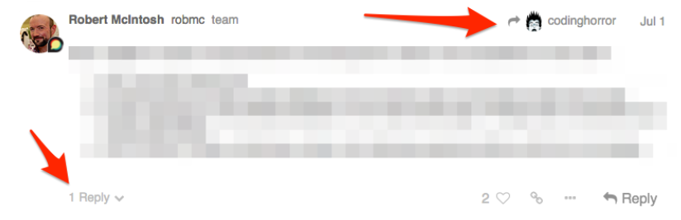

### Account Setup Instructions

* + Complete your profile: when signing into Discourse for the first time, go to your profile and add a bit of introduction of yourself.
  + Introduce yourself in the “Introductions” sub-category of the specialization you are interested in learning or building your network.
  + Get to know your peers and/or mentors
  + Discourse is about connecting, contributing and supporting. So, when you are ready, post your queries/suggestions/feedback as new topics and/or share your thoughts by replying to existing topic threads, click the like button for an existing topic, and do much more to build the community.

### Guidelines

* + Do not create duplicate threads to discuss topics that already exist.
  + Ensure you select the appropriate category and subcategory.
  + It is recommended to follow the below naming convention to give a title to your post. Use N/A if any of the parts of the naming convention are not applicable to your title.  
      
     *[Course Number]_[Week number]_[Item]_[Issue Description in short]*

Example 1: C4_W3_Exercise3_Grading error  
 Example 2: C1_W2_Reading Item_link not working

Example 3: C2_W1_Notebook_Lost previous work

Example 4: C3_N/A_N/A_Unable to access course

* + Avoid typing words in capital letters except when referring to well-known acronyms (ex: GANs).
  + On publicly visible threads, **do not share solutions**/answers to quizzes, notebooks, or graded lab related code.
  + Be kind to other members of the community.
  + Report inappropriate behavior to mentors or DeepLearning.AI staff. More information regarding this can be found in [Coursera’s code of conduct](https://coursera.community/site/terms)

### Tips

* + On clicking the logo at the top left corner of the screen, you will be navigated to the homepage of Discourse, no matter where you were previously.
  + **Bookmark**: bookmark a topic that you found helpful so you can easily find them. 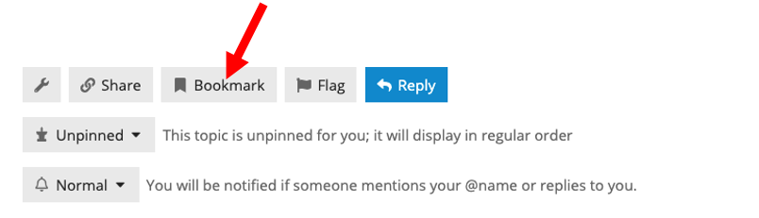You can review your list of bookmarks by clicking your profile image on the top right and choosing bookmarks.

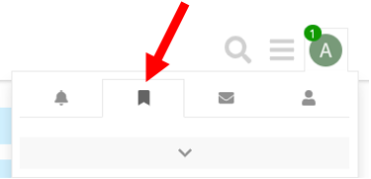

* + **Subscribing to categories and topics:**

To subscribe to a Topic (or thread) go to the topic, scroll to the bottom and click on the notifications dropdown.

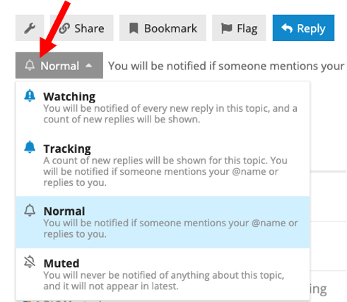

To subscribe to a Category, go to your preferences (via your Profile page) and click on Categories.

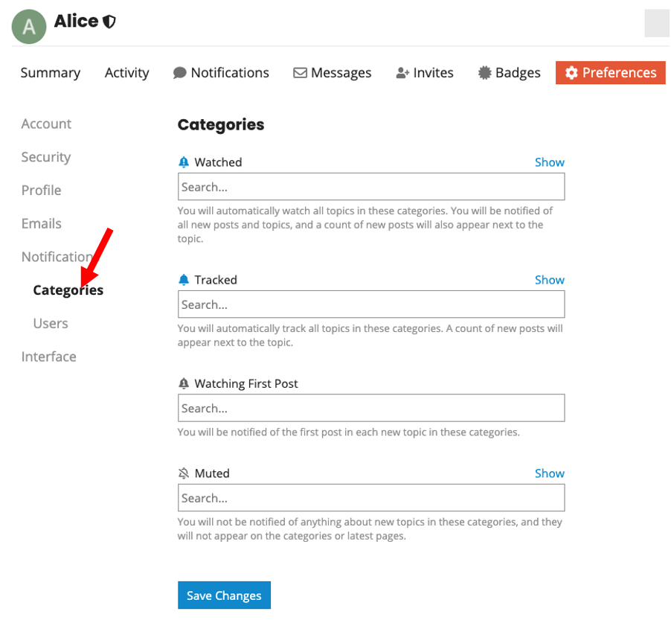

* + **Markdown**: Posts in Discourse are formatted using Markdown. When you create a post, you will see the raw markdown on the left and a preview on the right. Check out the [Markdown Cheatsheet](https://github.com/adam-p/markdown-here/wiki/Markdown-Cheatsheet) if you are not well versed with it and want a handy guide.
  + **Quoting**: To do a reply with quote, highlight the text you want to quote and a pop-up will appear saying "quote reply. Click it and that text will be copied to a new post. To reply to multiple posts in the same thread, repeat the process again until you get all your quotes.

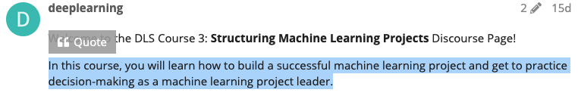

* + **Mentioning:** To notify someone about your reply, mention their name. Type @ to begin selecting a username. This search will also search the name fields in case you don’t know a particular username. Note - Please use mentioning only when needed otherwise you might be flagged for unnecessary tagging.
  + **Mark a reply as the solution:** As the topic creator you will have a button that allows you to accept an answer as the solution. Accepted answers will be highlighted on the initial topic and in the topic list.

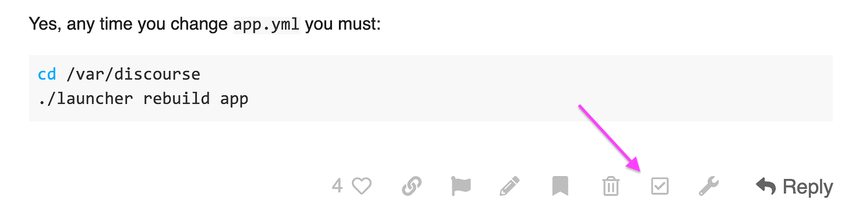

* + **Inserting an image**: Besides using the upload button in the composer toolbar, you can simply drag & drop (it even works for multiple images at once)
  + **Notifications:** When someone is talking directly to you — by replying to you, quoting your post, mentioning your @username , or even linking to your post, a blue number will immediately appear over your profile picture at the top right. Click your profile image to scroll through all your notifications.
  + **Voting:** For certain topics where you feel they are important topics of conversation for a particular course or if you come across these topics while searching for your issue and they help you solve them you can also vote(upvote) for the topic by clicking on blue vote button near the topic heading. 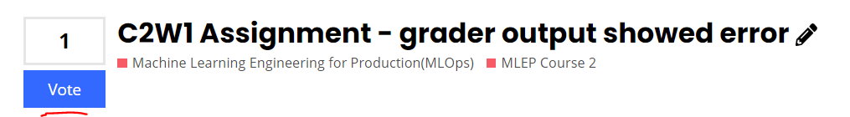

This helps in improving visibility of more upvoted topics and helps in putting more upvoted posts on top while someone searches for similar issues. You’ll see the vote button next to the topic. 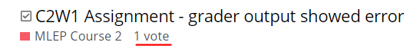

Remember that you have a limited number of votes to give on the platform (and only 1 vote per topic) so use this feature judiciously.

### User Trust Levels

Discourse relies on “Trust Levels.” They represent a natural progression for participants in the community, and as you interact more, you achieve higher levels of trust by the system. Below are the default starting levels for new users (i.e. learners) and mentors.

All new users start with Trust Level 1. They are able to:

* Use all core Discourse functions; all new user restrictions are removed
* Send PMs
* Upload images and attachments if enabled
* Edit wiki posts / regular posts
* Flag posts
* Mute other users

Mentors have Trust Level 3. Users with this Trust Level are able to:

* Recategorize and rename topics
* Access a secure category only visible to users at trust level 3 and higher
* Have all their links followed (we remove automatic nofollow)
* TL3 spam flags cast on TL0 user posts immediately hide the post
* TL3 flags cast on TL0 user posts in sufficient diversity will auto-silence the user and hide all their posts
* Make their own posts wiki (that is, editable by any TL1+ users)
* Daily like limit increased by 2×

**To learn more, here are some resources you can check out:**

* [User trust levels](https://blog.discourse.org/2018/06/understanding-discourse-trust-levels/)
* [Discourse New User Guide](https://meta.discourse.org/t/discourse-new-user-guide/96331)
* [Discourse Cheat sheet](https://www.sitepoint.com/community/t/discourse-cheat-sheet/733)

We are here to support you along the way. If you have any questions, thoughts or ideas, we’d love to hear it! You can either open a topic in the [General Site Feedback](https://discourse.deeplearning.ai/c/site-feedback/2) or email us at [community@deeplearning.ai](mailto:community@deeplearning.ai).

Thank you!